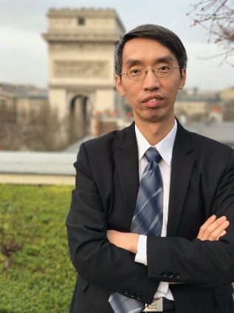
Ryan Hsieh
EVP, Head of Financial Investment
Taiwan Life Insurance Co., Ltd

Ryan Hsieh joined in CTBC Group since 2006, started from CTBC Venture and CTBC bank, been responsible for ventures capital, listed equities, and project finance investments. In 2012, Mr. Hsieh switched career path to Taiwan Life (CTBC Group's arms of acquired insurance subsidiary), served as Senior Vice President helped to consolidate the investment philosophy of acquired company and the Group.

As the head of Investment Division of Taiwan Life, Mr. Hsueh oversees over US$60 billion size of investment pool, conducting the investment strategies across equity, fixed income, and management of currency risks , and also supervising the assets and liabilities administration.

Prior to CTBC Group(2004-2006), Mr. Hsieh was the Special Assistant of Chairman of Askey Computer, provided evaluations and solutions to the company's expansion, span-off and M&A plans to the Board Mr. Hsieh was with RiTek for 3 years(2000-2003) executed strategic investment, spin-off and fundraising, Mr. Hsieh, began his career in Swire Coca-Cola Beverages(Taiwan).

Mr. Hsieh, holds a MS degree in Industrial Econo0mics from National Central University, and a BA from Feng Chia University in Taiwan.

